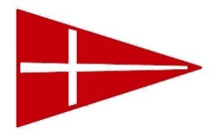
MHYC SAILING EVENT
LUNCH ORDER FORM
Latest cut-off for order submission: 11am Friday
Collection point is Sandbar from 8am
Boat name: _______________________
Contact number: _______________________
Email orders to: sailing@mhyc.com.au
Description | Price* | Saturday Qty. | Sunday Qty. | Total $
Ham, Cheese, & Tomato Sandwich | $9.50
Beef and Pickles Sandwich | $9.50
Grilled veggies and pesto sandwich | $9.50
Chicken Caesar Sandwich | $9.50
Schnitzel & coleslaw sandwich | $9.50
600ml water bottles | $2.00
Powerade | $6.00
Soft drink | $3.00

*No further discounts available
Additional drinks, food & 5kg ice bags will be available on the day from café.

Signature on pick up: ______________________________________
- - - - - - - - - - - - - - - - - - - - - - - - - - - - - - - - - - - - - - - - - - - - - - - - - - - - - - - - - - - - - - - - - - - - - - - - - - - - - - - - - - - - - - - - - - - - - - - - - - - - -
Signature: _________________________ TOTAL ON ORDER $________
C.C. details for pre-payment: Visa Mastercard AMEX

Card no: __ __ __ __ __ __ __ __ __ __ __ __ __ __ __ __ Total to be charged: $_______

Exp Date: __ / __ Name on card: __________________________________________

