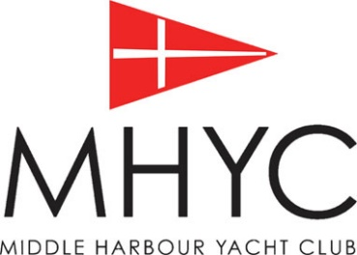
MHYC SAILING EVENT
LUNCH ORDER FORM

Latest cut off time for orders - 12noon the preceding Thursday
Collection time requested (earliest available - 8am): ________
Boat name: ___________________________
Contact number: _________________________
email to: sailing@mhyc.com.au

Description | Price* | Saturday Qty. | Sunday Qty. | Total $
10-person sandwich platter box. Various flavours. *note: items are not individually wrapped | $89.00
Ham, Cheese, & Tomato Sandwich | $9.20
Beef and Pickles Sandwich | $9.20
Grilled veggies and pesto sandwich | $9.20
Chicken Caesar Sandwich | $9.20
Schnitzel & coleslaw sandwich | $9.20
600ml water x 24 bottles | $24.00

*No further discounts available
Additional drinks, snacks & ice will be available on the day from café (open from 6:30am).

Signature: _________________________________ TOTAL ON ORDER $________

CC details for pre-payment: Visa Mastercard AMEX
Card no: __ __ __ __ __ __ __ __ __ __ __ __ __ __ __ __ Total to be charged: $_______
Exp Date: __ / __ Name on card: __________________________________________

