

Spurious Challenge Regatta
Friday 23 February 2018

SAILING INSTRUCTIONS

Organising Authority:

MIDDLE HARBOUR ASCHT CLUB
Lower Parriwi Road, The Spit, Mosman 2088
PO Box 106 Seaforth, NSW, 2092
P: (02) 9969 1244
F: (02) 9969 3326
Email: sailing @mhyc.com.au
Website: www.mhyc.com.au

RFI Technology Solutions
Mark Crosland:
P: (02) 88142332
F: (02) 9879 4974
Email: mark.crosland@rfi.com.au
Website: www.rfi.com

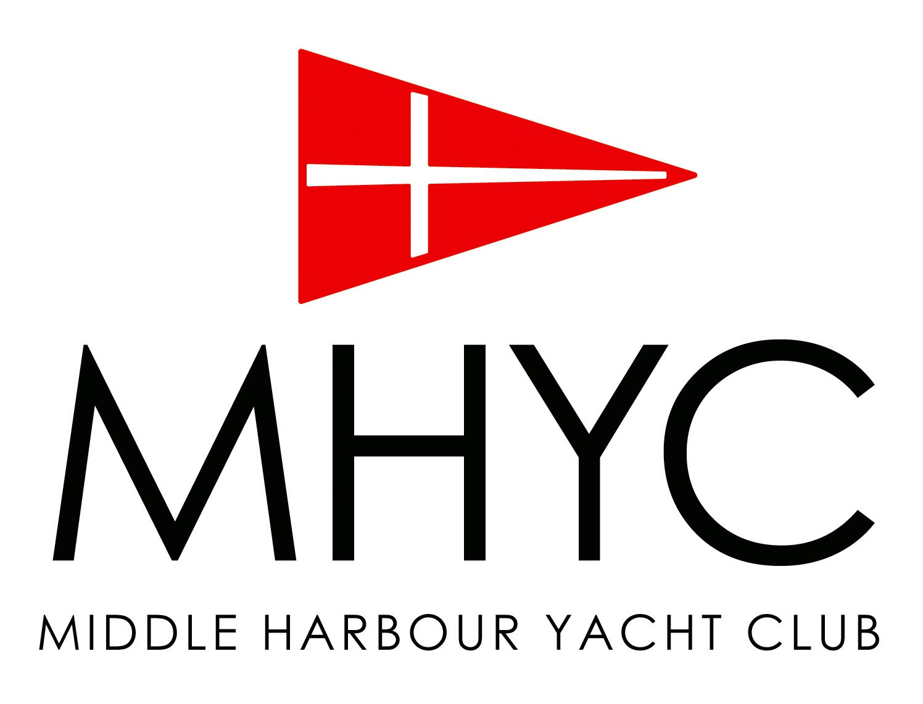
Spurious Challenge Regatta
Friday 23rd February 2018

SAILING INSTRUCTIONS

1 RULES
1.1 The Race will be governed by the following;
- the Rules as defined in the Racing Rules of Sailing (RRS),
- the Special Regulations of Australian Sailing (AS),
- the MHYC Safety Requirements (copies available from MHYC), and by
- the MHYC Conditions of Entry (attached to this Notice of Race).
1.2 The Race will be a ‘Pursuit’ race with a Handicapped starting sequence.
1.3 The Race will be categorized as ‘Non Spinnaker’. No sails shall be set forward of a mast which are not normally carried forward of that mast when working to windward. Only a mainsail and headsails as defined in RRS 50.4 shall be used. Headsails shall not be set flying.

2 NOTICES TO COMPETITORS
2.1 Notices to Competitors will be posted on the Official Notice Board which is located in the Breezeway of the MHYC Clubhouse.

3 CHANGES TO THE SAILING INSTRUCTIONS
3.1 Changes to these Sailing Instructions, if any, will be posted not later than 2 hours prior to the warning signal of the race.

4 SIGNALS
4.1 Signals made ashore will be displayed from the MHYC Race Official’s Box on the north-western perimeter of the Club premises.
4.2 Signals will be as follows:
1250hrs Warning Sound Signal & Course Number Displayed
1300hrs Start Sound Signal & Count Up Sequence Commenced
4.4 The display of the course number and the start of the count up sequence may each be accompanied by a sound signal. The failure or mis-timing of a sound signal shall be disregarded.

5 THE COURSE
5.1 The Courses are those annexed to these Sailing Instructions (Annexe A).
5.2 Courses may be shortened at any mark in accordance with RRS 32.
5.3 The attention of competitors is drawn to the MHYC NOR and those areas which are designated obstructions and prohibited areas in the vicinity of the Start and Finish lines, the Gowland Bombora and the Sow and Pigs Reef. A boat shall not sail into an area designated a prohibited area.

6 HANDICAP PURSUIT RACE
6.1 The race shall be a Handicap Pursuit Race with a Count Up start sequence.
6.2 A boat shall comply with the Special Regulations Part 1 for Category 7. An audited Special Regulations Form for the relevant Category (or higher) shall be submitted with the entry if not already held by MHYC.
6.3 The Regatta is designated non-spinnaker, only a mainsail and headsails as defined in RRS 50.4 shall be used. Headsails shall not be set flying. (No sail shall be set forward of a point of attachment of the permanent forestay.)
6.4 Start handicaps in minutes will be based on time correction factors (TCFs). A boat’s TCF shall be determined by the RC or its nominee.

6.5 Boats shall notify the MHYC Sailing Office not later than 2 days prior to a race of any change, addition or alteration to a boat’s hull appendages, equipment, sail inventory or skipper/crew that may affect its performance. At the discretion of the RC, a boat that fails to comply may be either disqualified after a hearing or have its results retrospectively adjusted by applying a new TCF based on the affect on the boat’s performance.
6.6 The TCF, and a boat’s start handicap based on it, shall not be subject to protest or constitute grounds for redress (amends RRS 60.1 and 62).
6.7 When only one boat starts and sails the course within the time limit, the RC shall not abandon the race (amends RRS 32).

7 THE START
7.1 The Start Line shall be at the Clubhouse. The Clubhouse start line is a transit formed by aligning two orange triangles located adjacent to the MHYC Race Official’s Box. The transit bears approximately 065°/245° magnetic.
7.2 The RC will allocate a starting handicap in minutes to each boat for the race. A boat shall not start before the Starters Clock has displayed its designated start handicap in minutes.
7.3 There will be no recalls. Any yacht deemed to have started prematurely and that has not returned and started correctly shall be penalised 5 minutes plus the difference between her starting handicap applied to her finish time. This amends RRS 29.

8 THE FINISH
8.1 The Finish Line shall be at the Clubhouse. The Clubhouse finish line is a transit formed by aligning two orange triangles located adjacent to the MHYC Race Official’s Box. The transit bears approximately 065°/245° magnetic.
8.2 A boat’s finish time shall be used for the calculation of its racing division results. The boat with the earliest finish time (after application of scoring penalties, if any) will be scored first.
8.3 All times will be recorded in minutes and whole seconds. Boats with equal finishing times shall be scored as dead heated.
8.4 All results will be subject to the application of Alternate Penalties, if any.

9 TIME LIMITS
9.1 The time limit will be 1700hrs on the day of racing.

10 ALTERNATIVE PENALTIES
10.1 For an infringement of RRS Part 2, the Two-Turns Penalty (RRS 44.2) shall apply.
10.2 For an infringement of any other rule or requirement, the Scoring Penalties of RRS 44.3 shall apply. The penalty shall be computed as a percentage of the number of entries in the relevant division.

11 ABANDONED RACES
11.1 Abandoned races will not be re-sailed.

12 RADIO COMMUNICATION
12.1 Yachts shall maintain a listening watch on VHF Channel 72 for the duration of the race.
12.2 Skippers approaching the MHYC Marina prior to the race for guest pick-up, shall contact MHYC Dockmaster on VHF Channel 73 for berthing instructions.

15 PRIZES
15.1 Prizes shall be presented at a post race presentation as per the Notice of Race.

16 RESPONSIBILITY
16.1 Competitors participate at their own risk. Special attention is drawn to RRS Fundamental Rule 4, which states: “The responsibility for a boat’s decision to participate in a race or to continue racing is hers alone”.
16.2 The Organising Authority, Event Sponsors (if applicable), and their respective officers, employees, volunteers and members accept no liability for any injury, loss or damage that may be suffered by any competitor, and any liability for harm to persons that results from breach of an express or implied warranty that the MHYC Race and all services relating thereto will be conducted or rendered with reasonable care and skill is excluded.
16.3 Neither MHYC, nor the event sponsor (if applicable), are responsible for the seaworthiness of a boat whose entry is accepted or the sufficiency or adequacy of its equipment.
Spurious Challenge Regatta
Friday 23rd February 2018

ANNEXE A - COURSES

A1 All marks are to be rounded to Starboard, unless suffixed (p) where they will be rounded to Port
A2 Boats in Division 3 shall omit marks prefixed (x) from the nominated course
Note: Competitors unfamiliar with Sydney Harbour are advised that a Course Chartlet is attached

Course 1  8.5 miles / 6.0 miles (approx.)  Start at MHYC Clubhouse  1 - (x) AS Mark Manly West  2 - (x) AS Mark Manly East  3 - AS Mark Cannae Point  4 - AS Mark Eastern Channel  5 - AS Mark Shark Island  6 - Shark Island  Finish at MHYC Clubhouse | Course 2  12.0 miles / 8.0 miles (approx.)  Start at MHYC Clubhouse  1 - AS Mark Manly West  2 - AS Mark Manly East  3 - AS Mark Eastern Channel  4 - (x) Fort Denison - p (Rounded to Port)  Finish at MHYC Clubhouse
Course 3  14.0 miles / 11.0 miles (approx.)  Start at MHYC Clubhouse  1 - AS Mark Shark Island  2 - Shark Island  3 - Fort Denison – p (Rounded to Port)  4 - AS Mark Manly West  5 - AS Mark Manly East  6 - (x) AS Mark Cannae Point  7 - (x) AS Mark East Channel  Finish at MHYC Clubhouse | Course 4  17.0 miles / 12.0 miles (approx.)  Start at MHYC Clubhouse  1 - AS Mark Shark Island  2 - Shark Island  3 - Fort Denison – p (Rounded to Port)  4 - AS Mark Manly West  5 - AS Mark Manly East  6 - AS Mark Cannae Point  7 - (x) AS Mark Shark Island  8 - (x) Shark Island  Finish at MHYC Clubhouse
Course 5  14.5 miles / 10.5 miles (approx.)  Start at MHYC Clubhouse  1 - AS Mark Manly West  2 - AS Mark Manly East  3 - AS Mark Cannae Point  4 - AS Mark East Channel  5 - (x) AS Mark Shark Island  6 - (x) Shark Island  7 - Fort Denison - p (Rounded to Port)  8 - (x) AS Mark Cannae Point  9 - (x) AS Mark East Channel  Finish at MHYC Clubhouse | Course 6  17.0 miles / 14.0 miles (approx.)  Start at MHYC Clubhouse  1 - AS Mark Manly West  2 - AS Mark Manly East  3 - AS Mark Cannae Point  4 - AS Mark East Channel  5 - (x) AS Mark Shark Island  6 - (x) Shark Island  7 - Fort Denison - p (Rounded to Port)  8 - AS Mark Cannae Point  9 - AS Mark East Channel  10 - (x) AS Mark Shark Island  11 - (x) Shark Island  Finish at MHYC Clubhouse

Spurious Challenge Regatta
Friday 23rd February 2018

ANNEXE B – MHYC COURSE CHARTLET
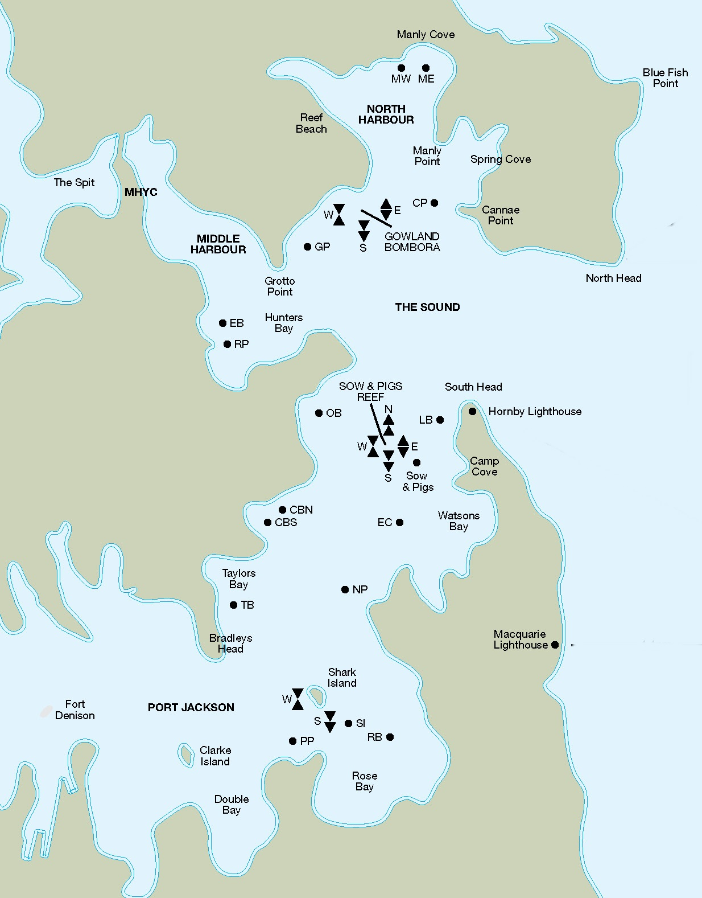

Spurious Challenge Regatta
Friday 23rd February 2018

ANNEXE C – MHYC MARINA MAP

